**Name:** Mozeb Ahmed Khan

**Roll No:** 20F-0161

**Section:** BS (CS)-6C

**Course:** Web Programming

**Lab No:** 03

**Task 1:**

**Code:**

<!DOCTYPE html>

<html lang="en">

<head>

    <meta charset="UTF-8">

    <meta name="viewport" content="width=device-width, initial-scale=1.0">

    <title>Task 1</title>

    <link rel="stylesheet" href="https://cdn.jsdelivr.net/npm/bootstrap@5.3.2/dist/css/bootstrap.min.css">

    <script src="https://cdn.jsdelivr.net/npm/bootstrap@5.3.2/dist/js/bootstrap.bundle.min.js"></script>

</head>

<body>

   <div class="container mt-3">

      <div class="alert alert-success alert-dismissible">

         <a href="https://www.w3schools.com/bootstrap/bootstrap_ver.asp" target="_blank" class="alert-link" style="text-decoration: none;">Feel good about Bootstrap</a>

         <button type="button" class="btn-close" data-bs-dismiss="alert"></button>

      </div>

      <div class="alert alert-info alert-dismissible">

         <a href="https://www.w3schools.com/bootstrap/bootstrap_ver.asp" target="_blank" class="alert-link" style="text-decoration: none;">Feel informed about Bootstrap</a>

         <button type="button" class="btn-close" data-bs-dismiss="alert"></button>

      </div>

      <div class="alert alert-warning alert-dismissible">

         <a href="https://www.w3schools.com/bootstrap/bootstrap_ver.asp" target="_blank" class="alert-link" style="text-decoration: none;">Feel warned about Bootstrap</a>

         <button type="button" class="btn-close" data-bs-dismiss="alert"></button>

      </div>

      <div class="alert alert-warning alert-dismissible">

         <a href="https://www.w3schools.com/bootstrap/bootstrap_ver.asp" target="_blank" class="alert-link" style="text-decoration: none;">Maybe I should read the docs...</a>

         <button type="button" class="btn-close" data-bs-dismiss="alert"></button>

      </div>

      <div class="alert alert-danger alert-dismissible">

         <a href="https://www.w3schools.com/bootstrap/bootstrap_ver.asp" target="_blank" class="alert-link" style="text-decoration: none;">Danger zone</a>

         <button type="button" class="btn-close" data-bs-dismiss="alert"></button>

      </div>

      <div class="alert alert-danger alert-dismissible">

         <a href="https://www.w3schools.com/bootstrap/bootstrap_ver.asp" target="_blank" class="alert-link" style="text-decoration: none;">I really should read the docs...</a>

         <button type="button" class="btn-close" data-bs-dismiss="alert"></button>

      </div>

   </div>

</body>

</html>

**Output:**

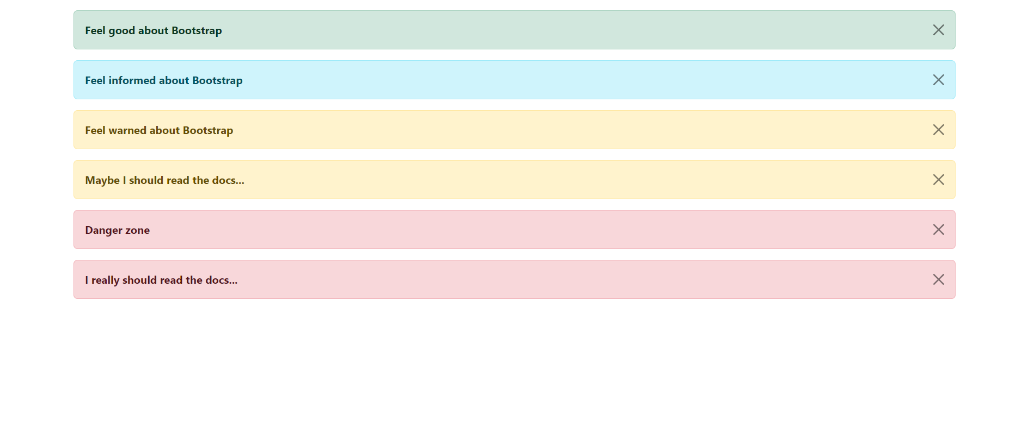

**Task 2:**

**Code:**

<html lang="en">

<head>

    <meta charset="UTF-8">

    <meta name="viewport" content="width=device-width, initial-scale=1.0">

    <link rel="stylesheet" href="https://cdn.jsdelivr.net/npm/bootstrap@5.3.2/dist/css/bootstrap.min.css">

    <script src="https://cdn.jsdelivr.net/npm/bootstrap@5.3.2/dist/js/bootstrap.bundle.min.js"></script>

    <title>Task 2</title>

</head>

<body>

    <div class="container mt-3">

        <br><br><br><br>

        <button type="button" class="btn" style="background-color: rgb(248, 248, 248);" onclick="alertMessage('Basic button clicked')">Basic</button>

        <button type="button" class="btn btn-default" style="background-color: rgb(240, 240, 240);border: 1px solid rgb(180, 180, 180);" onclick="alertMessage('Default button clicked')">Default</button>

        <button type="button" class="btn btn-primary" onclick="alertMessage('Primary button clicked')">Primary</button>

        <button type="button" class="btn btn-success" onclick="alertMessage('Success button clicked')">Success</button>

        <button type="button" class="btn btn-info" style="color: white;" onclick="alertMessage('Info button clicked')">Info</button>

        <button type="button" class="btn btn-warning" style="color: white;" onclick="alertMessage('Warning button clicked')">Warning</button>

        <button type="button" class="btn btn-danger" onclick="alertMessage('Danger button clicked')">Danger</button>

        <button type="button" class="btn btn-link" style="text-decoration: none;" onclick="alertMessage('Link button clicked')">Link</button>

    </div>

    <script>

        function alertMessage(msg) {

            alert(msg);

        }

    </script>

</body>

</html>

**Output:**

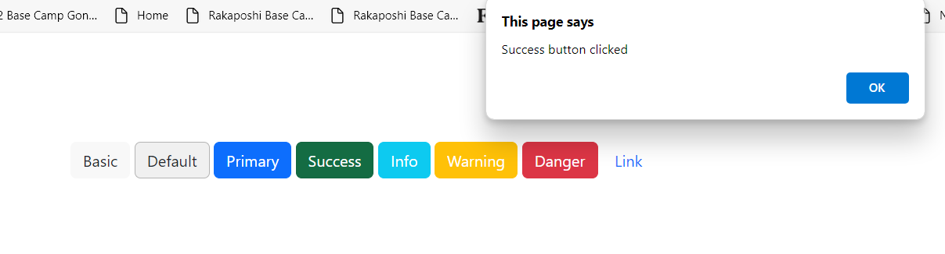

**Task 3:**

**Code:**

<html lang="en">

<head>

    <meta charset="UTF-8">

    <meta name="viewport" content="width=device-width, initial-scale=1.0">

    <link rel="stylesheet" href="https://cdn.jsdelivr.net/npm/bootstrap@5.3.2/dist/css/bootstrap.min.css">

    <script src="https://cdn.jsdelivr.net/npm/bootstrap@5.3.2/dist/js/bootstrap.bundle.min.js"></script>

    <title>Task 3</title>

</head>

<body>

    <h2>A Javascript program that add, subtract, multiply, divide two numbers</h2>

    <p>Please enter two numbers in the input: </p>

    <form action="Calculate()">

        <label for="num1">Num 1: </label>

        <input type="text" id="num1" name="num1" placeholder="number 1" required>

        <label for="num2">Num 2: </label>

        <input type="text" id="num2" name="num2" placeholder="number 2" required>

        <button type="button" class="btn btn-primary" onclick="Calculate()">Calculate</button>

    </form>

    <div>

        <p id="add"></p>

        <p id="sub"></p>

        <p id="mul"></p>

        <p id="div"></p>

    </div>

    <script>

        function Calculate()

        {

            let num1=parseFloat(document.getElementById('num1').value);

            let num2=parseFloat(document.getElementById('num2').value);

            /*Addition*/

            let add=num1+num2;

            document.getElementById("add").innerHTML="Addition: " + add;

            /*Subtraction*/

            let sub=0;

            if (num1>num2) {

                sub=num1-num2;

            }

            else {

                sub=num2-num1;

            }

            document.getElementById("sub").innerHTML="Subtraction: " + sub;

            /*Multiplication*/

            let mul=num1*num2;

            document.getElementById("mul").innerHTML="Multiplication: " + mul;

            /*Division*/

            let div=num1/num2;

            document.getElementById("div").innerHTML="Division: " + div;

        }

    </script>

</body>

</html>

**Output:**

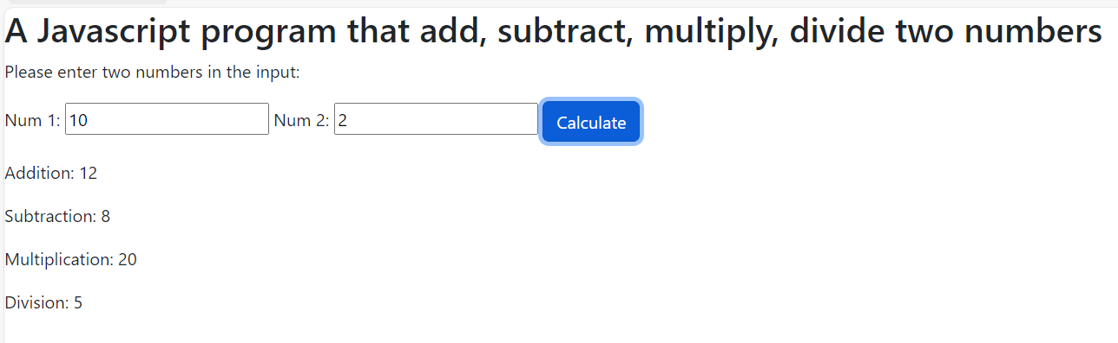

**Task 4:**

**Code:**

<html lang="en">

<head>

    <meta charset="UTF-8">

    <meta name="viewport" content="width=device-width, initial-scale=1.0">

    <link rel="stylesheet" href="https://cdn.jsdelivr.net/npm/bootstrap@5.3.2/dist/css/bootstrap.min.css">

    <script src="https://cdn.jsdelivr.net/npm/bootstrap@5.3.2/dist/js/bootstrap.bundle.min.js"></script>

    <title>Task 4</title>

</head>

<body>

    <h2>A javascript program that takes the month as input and display the number of days.</h2>

    <p>Please enter the month name: (like Jan, Feb etc.)</p>

    <form>

        <label for="month">Month: </label>

        <input type="text" name="month" id="month" placeholder="enter month" required>

        <button type="button" class="btn btn-success" onclick="findDays()">Find Days</button>

    </form>

    <div>

        <p id="days"></p>

    </div>

    <script>

        function findDays()

        {

            const Month=[

                {monthName: "Jan", noOfDays: 31},

                {monthName: "Feb", noOfDays: 28},

                {monthName: "Mar", noOfDays: 31},

                {monthName: "Apr", noOfDays: 30},

                {monthName: "May", noOfDays: 31},

                {monthName: "Jun", noOfDays: 30},

                {monthName: "Jul", noOfDays: 31},

                {monthName: "Aug", noOfDays: 31},

                {monthName: "Sep", noOfDays: 30},

                {monthName: "Oct", noOfDays: 31},

                {monthName: "Nov", noOfDays: 30},

                {monthName: "Dec", noOfDays: 31},

            ]

            monthname=document.getElementById('month').value;

            daysnumber=document.getElementById('days');

            let n=-1;

            for (let i = 0; i < Month.length; i++) {

                if (monthname.toLowerCase()===Month[i].monthName.toLowerCase())

                {

                    n=i;

                    break;

                }

            }

            if (n!==-1) {

                daysnumber.innerHTML="No. of Days: " + Month[n].noOfDays;

            } else {

                daysnumber.innerHTML="Please enter a valid input.";

            }

        }

    </script>

</body>

</html>

**Output:**

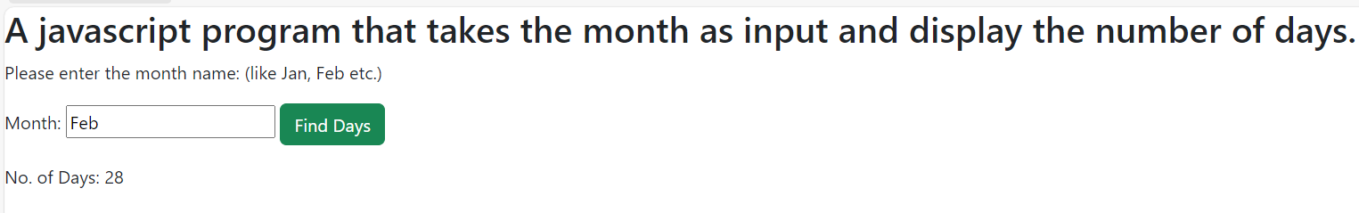

**Task 5:**

**Code:**

<html lang="en">

<head>

    <meta charset="UTF-8">

    <meta name="viewport" content="width=device-width, initial-scale=1.0">

    <link rel="stylesheet" href="https://cdn.jsdelivr.net/npm/bootstrap@5.3.2/dist/css/bootstrap.min.css">

    <script src="https://cdn.jsdelivr.net/npm/bootstrap@5.3.2/dist/js/bootstrap.bundle.min.js"></script>

    <title>Task 5</title>

</head>

<body>

    <h2>Program to ask user for an input and print its table.</h2>

    <p>Please enter a number: </p>

    <input type="number" name="number" id="num">

    <button onclick="TableGenerator()" type="button" class="btn btn-primary">Generate Table</button>

    <p id="Result"></p>

    <script>

        function TableGenerator() {

            let number=document.getElementById('num').value;

            let table='';

            for (let i = 1; i <= 10; i++) {

                let Result=i*number;

               table+=number + " x " + i + " = " + Result + "<br>";

            }

            document.getElementById('Result').innerHTML=table;

        }

    </script>

</body>

</html>

**Output:**

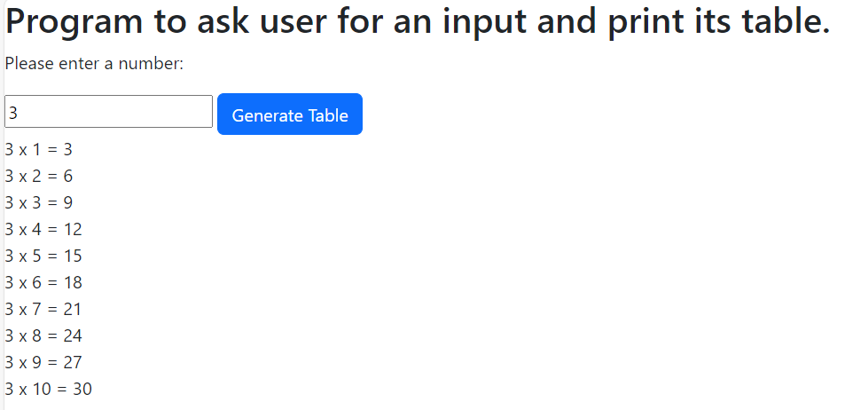

**The End.**